Loops 2: install packages via loops

vi loops2.yml

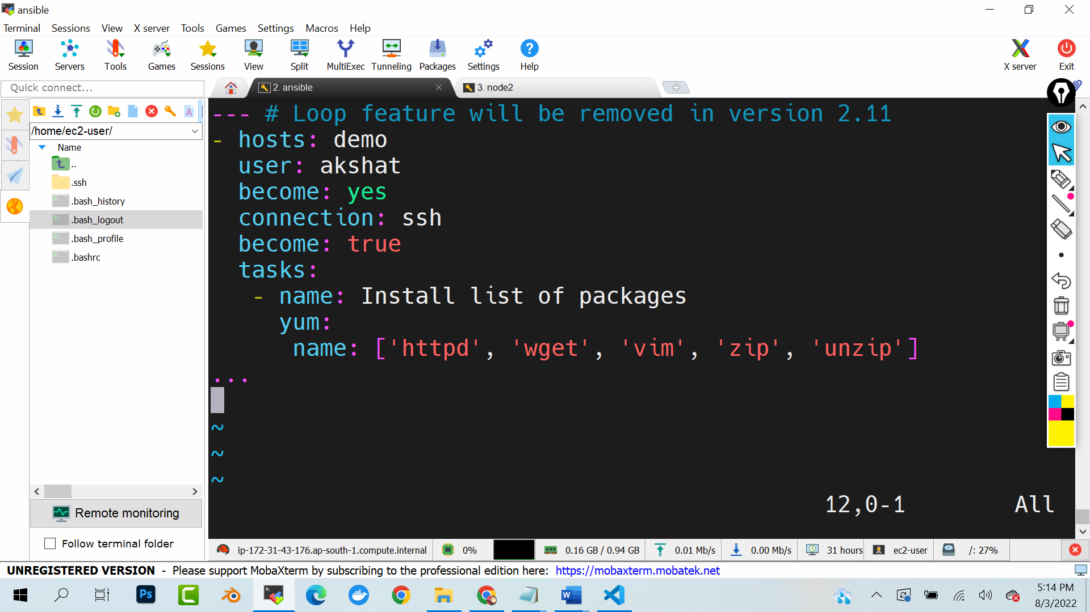

(code is there in google drive in ansible -> playbooks -> loops2.yml

Ansible-playbook loops2.yml

Now go to any node

which httpd

which wget

which vim